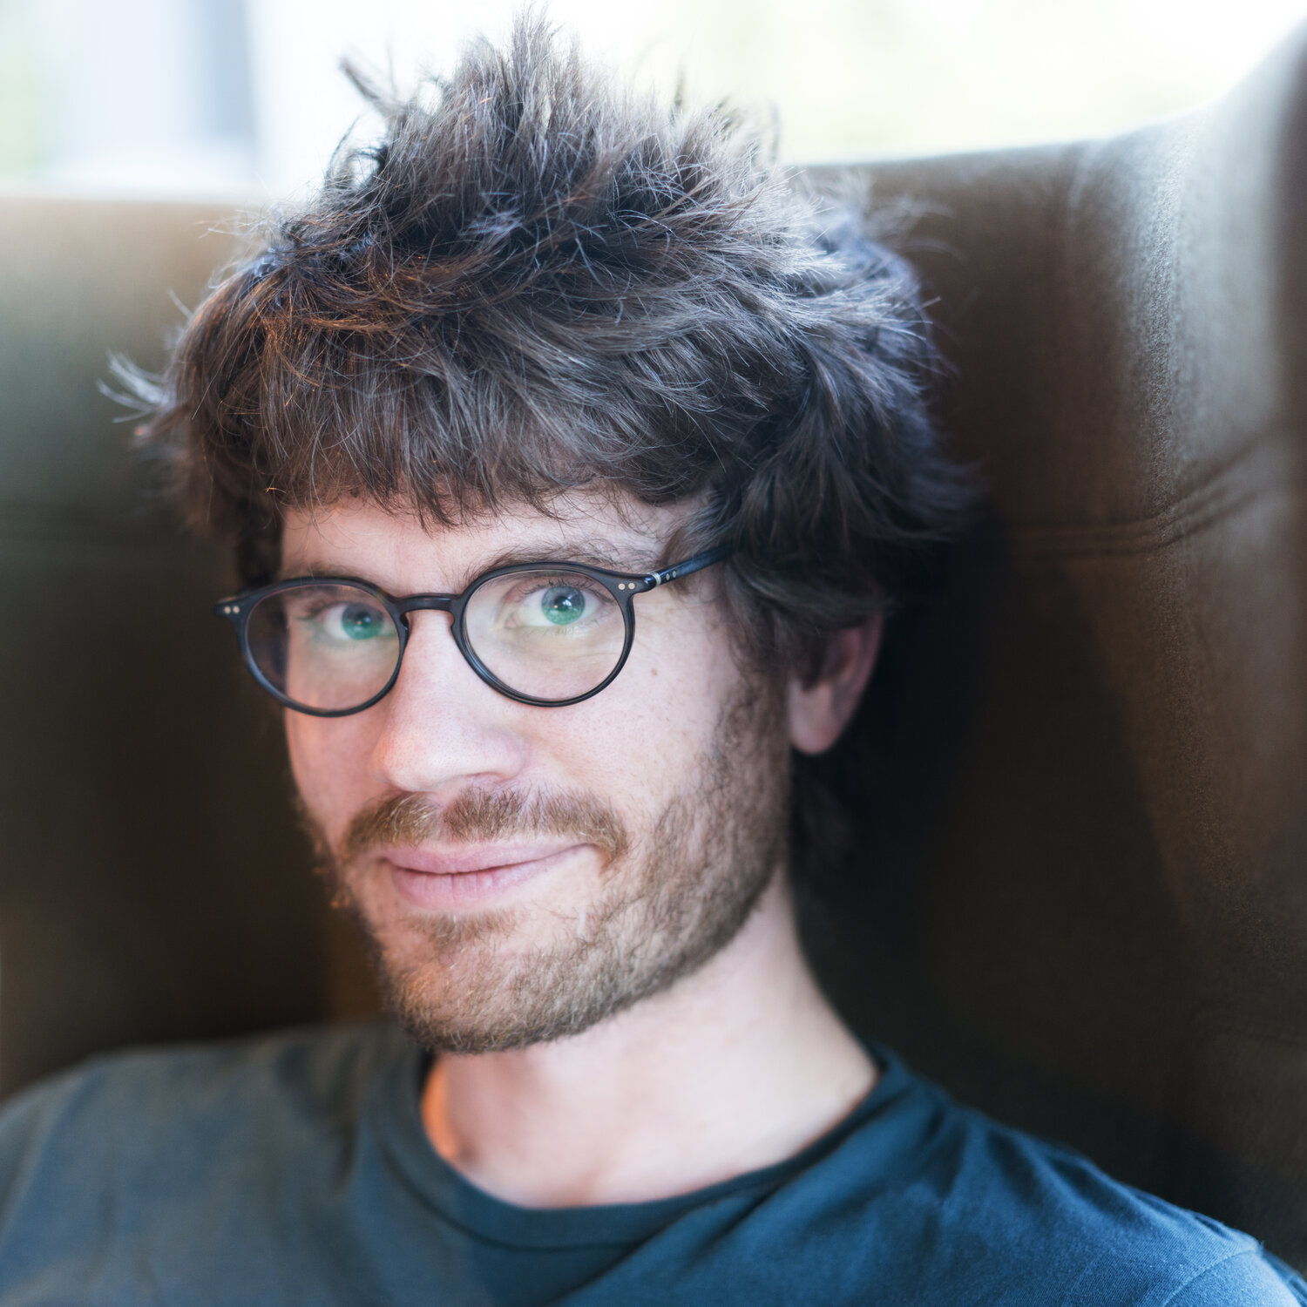

MSc Oxford University (UK)

Managing Director at The Social Innovation Partnership

PhD LMU Munich (Germany)

Artificial Intelligence Resident at Google

BSc University of Waterloo

Software Engineer at Google

PhD Cambridge University (UK)

Professor at Simon Fraser University

BSc University of Toronto

Senior Software Engineer at Netflix

MSc Stanford University (USA)

Director of Engineering at Instagram

12 MAY

16 JUN

# Genevieve Laurier

# Leonard Zgrablic

# Evan Browning

# Thomas Dimson



2021 Lecture Series

10 FEB

# Brianne Kent

10 MAR

# Ahmed Omran

24 FEB

14 APR